EXPERIMENT NO. 1

Aim: Study of Different Type of LAN, Network Equipments & system.

- Repeater
- Hub
- Switch
- Bridge
- Router
- Gate Way
Apparatus Required

No software or hardware needed

Theory

- Repeater: Functioning at Physical Layer. A repeater is an electronic device that receives a signal and retransmits it at a higher level and/or higher power, or onto the other side of an obstruction, so that the signal can cover longer distances. Repeaters have two ports, so cannot be used to connect for more than two devices.
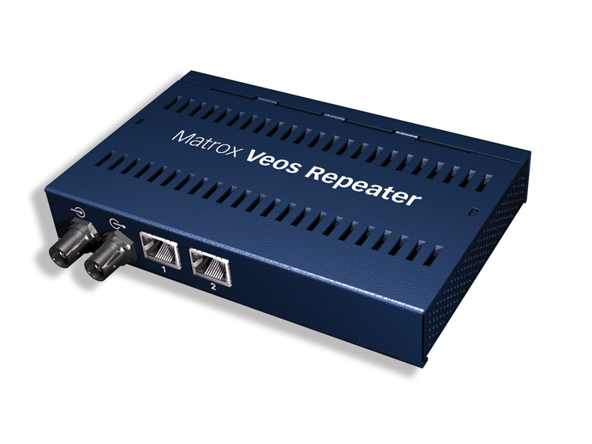
- Hub: An Ethernet hub, active hub, network hub, repeater hub, hub or concentrator is a device for connecting multiple twisted pair or fiber optic Ethernet devices together and making them act as a single network segment. Hubs work at the physical layer of the OSI model. The device is a form of multiport repeater. Repeater hubs also participate in collision detection, forwarding a jam signal to all ports if it detects a collision. 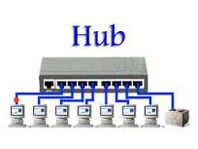
- Switch: A network switch or switching hub is a computer networking device that connects network segments. The term commonly refers to a network bridge that processes and routes data at the data link layer of the OSI model. Switch that additionally process data at the network layer are often referred to as layer 3 switches or multilayer switches. 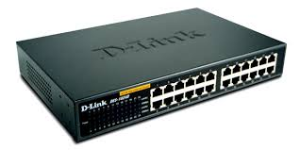
- Bridge: A network bridge connects multiple network segments at the data link layer of the OSI model. In Ethernet networks, the term bridge formally means a device that behaves according to the IEEE 802.1 D standards. A bridge and switch are very much alike; a switch being a bridge with numerous ports. Switch of layer 2 switch is often used interchangeably with bridge. Bridges can analyze incoming data packets to determine if the bridge is able to send the given packet to another segment of the network. 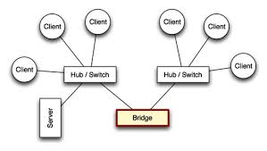
- Router: A router is an electronic device that interconnects two or more computer networks, and selectively interchanges packets of data between them. Each data packet contains address information that a router can use to determine if the source and destination are on the same network, or if the data packet must be transferred from one network to another. Where multiple routers are used in a large collection of interconnected networks, the routers exchange information about target system addresses, so that each router can build up a table showing the preferred paths between any two systems on the interconnected networks. 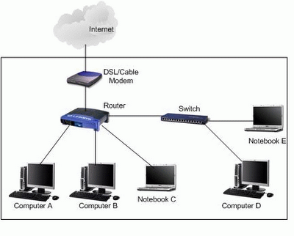
- Gate way: In a communications network, a network node equipped for interfacing with another network that uses different protocols.
A gateway may contain devices such as protocol translators, impedance matching devices, rate converters, fault isolators, or signal translators as necessary to provide system interoperability. It also requires the establishment of mutually acceptable administrative procedures between both networks.
A protocol translation/mapping gateway interconnects networks with different network protocol technologies by performing the required protocol conversions.
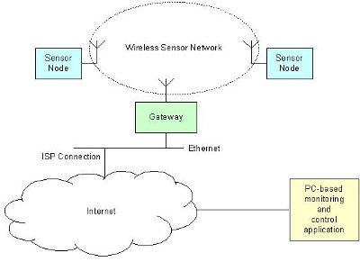

Conclusions
Different Network Devices have been studied in detail.

EXPERIMENT NO. 2
Aim: Study and verification of standard Network topologies i.e. Star, Bus, Ring etc.

Theory
Network topology is the arrangement of the various elements (links, nodes, etc.) of a computer or biological network. Essentially, it is the topological structure of a network, and may be depicted physically or logically. Physical topology refers to the placement of the network's various components, including device location and cable installation, while logical topology shows how data flows within a network, regardless of its physical design. Distances between nodes, physical interconnections, transmission rates, and/or signal types may differ between two networks, yet their topologies may be identical.
A good example is a local area network (LAN): Any given node in the LAN has one or more physical links to other devices in the network; graphically mapping these links results in a geometric shape that can be used to describe the physical topology of the network. Conversely, mapping the data flow between the components determines the logical topology of the network.

Topology
There are two basic categories of network topologies:
- Physical topologies
- Logical topologies
The shape of the cabling layout used to link devices is called the physical topology of the network. This refers to the layout of cabling, the locations of nodes, and the interconnections between the nodes and the cabling The physical topology of a network is determined by the capabilities of the network access devices and media, the level of control or fault tolerance desired, and the cost associated with cabling or telecommunications circuits.
The logical topology, in contrast, is the way that the signals act on the network media, or the way that the data passes through the network from one device to the next without regard to the physical interconnection of the devices. A network's logical topology is not necessarily the same as its physical topology. For example, the original twisted pair Ethernet using repeater hubs was a logical bus topology with a physical star topology layout. Token Ring is a logical ring topology, but is wired a physical star from the Media Access Unit.
The logical classification of network topologies generally follows the same classifications as those in the physical classifications of network topologies but describes the path that the data takes between nodes being used as opposed to the actual physical connections between nodes. The logical topologies are generally determined by network protocols as opposed to being determined by the physical layout of cables, wires, and network devices or by the flow of the electrical signals, although in many cases the paths that the electrical signals take between nodes may closely match the logical flow of data, hence the convention of using the terms logical topology and signal topology interchangeably.
Logical topologies are often closely associated with Media Access Control methods and protocols. Logical topologies are able to be dynamically reconfigured by special types of equipment such as routers and switches.
The study of network topology recognizes eight basic topologies:
- Point-to-point
- Bus
- Star
- Ring or circular
- Mesh
- Tree
- Hybrid
- Daisy chain
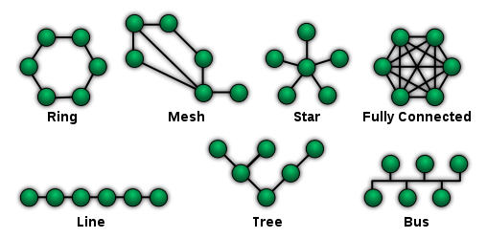

EXPERIMENT NO. 3

Aim: LAN installations and their Configurations.

Theory
Performance: Perform the following steps as directed

Step 1: To make a Direct Cable connection
1. Click Start, click Control Panel, and then double-click Network Connections.
2. Under Network Tasks, click Create a new connection, and then click next.
3. Click Set up an advanced connection, and then click next.
4. Click Connect directly to another computer, and click next.
5. Choose the role this machine will play in the communication. If this computer has the information to which you need to gain access, click Host. If this computer will access information from the other computer, click Guest.

Step 2: To Set Up the Host Computer
1. Click the connection device that you want to use for this connection (a parallel or serial port, or an infrared port), and then click Next.
2. Grant access to the users who are allowed to connect by selecting the appropriate check boxes, and then click Next.
3. Click Finish to end the configuration process.

Step 3: to Set up the Guest Computer
1. Type a name to identify this connection, and then click Next.
2. Click the connection device that you want to use for this connection (a parallel or serial port, or an infrared port), and then click Next.
3. Decide whether this connection will be available for all users (click Anyone's use), or only for you (click my use only), and then click Next.
4. Click Finish to end the setup process

Step 4: To create Windows Workgroup
1. In Windows XP, right click on My Computer, select System Properties.
2. Select the Computer Name tab, click on Change.
3. Enter the appropriate Computer name and Workgroup.
4. Make sure that every computer on your home network references the same workgroup.

Step 5:
To Configure TCP/IP To assign IP address, gateway, subnet mask, DNS
Step 6:
To create domain Bring all the PC of Lab under a network using workgroup or domain.
Create client and server
Result/ Conclusions
Windows workgroup is established and used for sharing and transferring data between physically connected PCs.

EXPERIMENT NO. 4

Aim: To implement various types of error correcting techniques.

Theory
Error detection and correction are implemented either at the data link layer or the transport layer of the OSI model.
Types of Errors

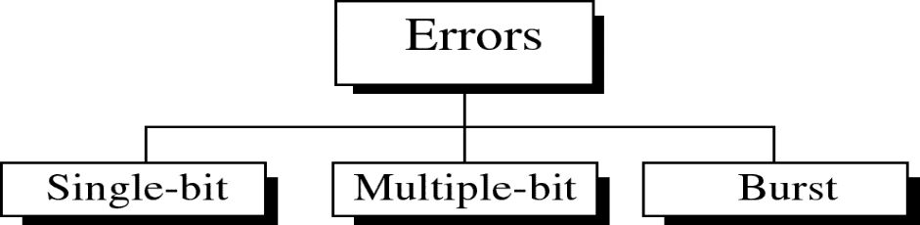

Single-bit error

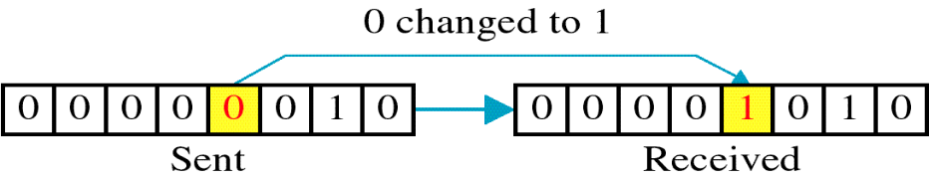

Single bit errors are the least likely type of errors in serial data transmission because the noise must have a very short duration which is very rare. However this kind of errors can happen in parallel transmission.

Example:
- If data is sent at 1Mbps then each bit lasts only 1/1,000,000 sec. or 1 μs.
- For a single-bit error to occur, the noise must have a duration of only 1 μs, which is very rare.

Burst error
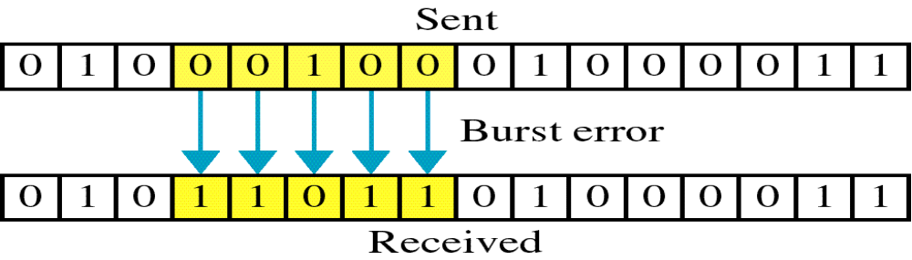

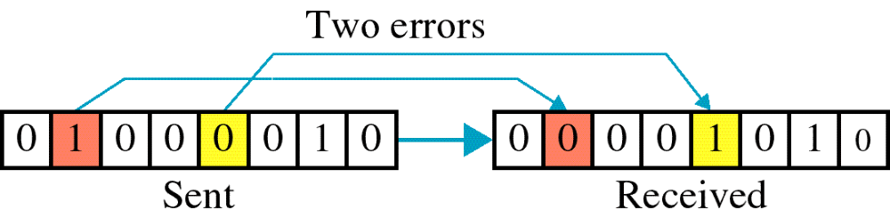

The term burst error means that two or more bits in the data unit have changed from 1 to 0 or from 0 to 1.
Burst errors do not necessarily mean that the errors occur in consecutive bits, the length of the burst is measured from the first corrupted bit to the last corrupted bit. Some bits in between may not have been corrupted.
Burst error is most likely to happen in serial transmission since the duration of noise is normally longer than the duration of a bit.
The number of bits affected depends on the data rate and duration of noise.
Example:

If data is sent at rate = 1Kbps then a noise of 1/100 sec can affect 10 bits.(1/100*1000)
If same data is sent at rate = 1Mbps then a noise of 1/100 sec can affect 10,000 bits.(1/100*10⁶)

CYCLIC REDUNDANCY CHECK (CRC)
LOGIC:
1. Let r be the degree of G(x).Append r zero bits to the low-order end of the frame. So it now contains m+r bits and corresponds to the polynomial x2 m(x).
2. Divide the bit string corresponding to G(x) into the bit string corresponding to x2 m(x) using modulo-2 division.
3. Subtract the remainder from the bit string corresponding to x2 m(x) using modulo-2 sub. The result is the check summed frame to be transmitted. We call it as a polynomial.

EXPERIMENT NO. 5

Aim - Write a program to Implement various types of framing methods.

CHARACTER COUNT

Aim:Implementation of data link framing methods for counting characters in a given frame

LOGIC: The header in the given frame is by default first frame size including the first field data bits are counted and considered as the first frame and the next field contains the next frame size and so on. PSEUDO CODE:
1. At the sender side the user is asked to enter the number of frames he want to transmit.
2. Depending upon the input, that much number of frames are taken as input from the user and stored in a 2 by 2 matrix.
3. The length of each frame is calculated and stored in a new array.
4. While out putting the frame, the length of each frame is added to the each frame and finally all the frames are appended and sent as a single string.
5. At the receiver side, the first number is treated as the length of the first frame and the string is extracted and displayed.
6. The next number is treated as the length of the next frame and so on.

At Sender:
INPUT:
Enter the number of frames you want to send: 2
Enter the frame: 1234
Enter the frame: 678
OUTPUT
The transmitted frame is: 512344678

At receiver:
INPUT:
Enter data 512344678
OUTPUT:
Frame sizes are: 5 4
Frames are:
Frame 1: 1234
Frame 2: 678

BIT STUFFING

AIM :-Implementation of the data link framing methods for the bit stuffing in a frame.

LOGIC: Stuffing a 0 bit in a data frame in order to differentiate the header, trailer and data.

PSEUDO CODE: /* For given data */

1. a flag “01111110” is embedded at the starting and the ending of the data. /* stuffing of data */
2. if data bit is 1 increment count else count is zero.
3. If count is five store a zero bit after the five 1‟s in the data array.
4. Repeat step 3 till the end of data. /* De stuffing of data */
5. If the data bit is 1 increment count else count is zero.
6. If the count is five and the next bit is zero then store the next bit after zero in the data array. /* transmit the data */
7. De stuffed data is transmitted without flags.

At sender:
INPUT:
Enter the string 1111110101
OUTPUT:
Transmitted data is: 01111110111111010101111110
Stuffed data is: 011111101111101010101111110

At Receiver:
INPUT:
Enter the string 1111110101
OUTPUT:
De stuffed data is: 11111110101

CHARACTER STUFFING

AIM:- Implementation of data link framing methods for character stuffing in a frame.

LOGIC: In a character data frame if a DLE is encountered between the data it is doubled and transmitted at the receiver side it is de stuffed and original data is obtained.

PSEUDO CODE: /* Defining DLE characters */

1. As the DLE characters are non-printable characters. The ASCII values of the printable characters like *, #, $ are assigned to DLE, STX, ETX.

/*Stuffing the data */

2. If the ASCII value that is assigned to DLE occurs in the data array another DLE character is stuffed and stored in the array and transmitted along with starting and ending flags /* DE stuffing data */

3. If the ASCII value of DLE occurs in the data array, the next bit is stored in to the array and transmitted without the flags.

4. Here whenever the program encounters characters like * the string DLE is added to the original string.

At Sender:
INPUT:
Enter Data r*gm
OUTPUT:
Stuffed data DLESTXrDLEDLEgmDLEETX

At receiver:
OUTPUT:
The message: r*gm

EXPERIMENT NO. 6

Study and Installation of Standard Network Simulator
In communication and computer network research, network simulation is a technique where a program models the behavior of a network either by calculating the interaction between the different network entities (hosts/routers, data links, packets, etc.) using mathematical formulas, or actually capturing and playing back observations from a production network. The behavior of the network and the various applications and services it supports can then be observed in a test lab; various attributes of the environment can also be modified in a controlled manner to assess how the network would behave under different conditions. When a simulation program is used in conjunction with live applications and services in order to observe end-to-end performance to the user desktop, this technique is also referred to as network emulation.

Network simulator
A network simulator is a piece of software or hardware that predicts the behavior of a network, without an actual network being present. A network simulator is a software program that imitates the working of a computer network. In simulators, the computer network is typically modeled with devices, traffic etc. and the performance is analyzed. Typically, users can then customize the simulator to fulfill their specific analysis needs. Simulators typically come with support for the most popular protocols in use today, such as WLAN, Wi-Max, UDP, and TCP.

Simulations
- Most of the commercial simulators are GUI driven, while some network simulators require input scripts or commands (network parameters). The network parameters describe the state of the network (node placement, existing links) and the events (data transmissions, link failures, etc.). An important output of simulations is the trace files. Trace files can document every event that occurred in the simulation and are used for analysis. Certain simulators have added functionality of capturing this type of data directly from a functioning production environment, at various times of the day, week, or month, in order to reflect average, worst-case, and best-case conditions. Network simulators can also provide other tools to facilitate visual analysis of trends and potential trouble spots.
- Most network simulators use discrete event simulation, in which a list of pending "events" is stored, and those events are processed in order, with some events triggering future events—such as the event of the arrival of a packet at one node triggering the event of the arrival of that packet at a downstream node.
- Some network simulation problems, notably those relying on queueing theory, are well suited to Markov chain simulations, in which no list of future events is maintained and the simulation consists of transiting between different system "states" in a memory less fashion. Markov chain simulation is typically faster but less accurate and flexible than detailed discrete event simulation. Some simulations are cyclic based simulations and these are faster as compared to event based simulations.
- Simulation of networks can be a difficult task. For example, if congestion is high, then estimation of the average occupancy is challenging because of high variance. To estimate the likelihood of a buffer overflow in a network, the time required for an accurate answer can be extremely large. Specialized techniques such as "control variants" and "importance sampling" have been developed to speed simulation.

Examples of network simulators
Examples of notable network simulation software are, ordered after how often they are mentioned in research papers:
- ns2/ns3
- OPNET
- NetSim
- NS (simulator)
Ns (from network simulator) is a name for series of discrete eventnetwork simulators, specifically ns-1, ns-2 and ns-3. These simulators are used in the simulation of routing protocols, among others, and are heavily used in ad-hoc networking research, and support popular network protocols, offering simulation results for wired and wireless networks alike.

Design
Ns-3 is built using C++ and Python and scripting is available with either language. Split over 30 modules, features of ns-3 include:
- Callback-driven events
- Attribute system that manages default and per-object simulation values
- Helpers that allow using simpler API when configuring simulations

Workflow for ns
It includes four steps:
- Implement protocol models
- Setup simulation scenario, i.e. create Tcl file describing type of scenario, e.g. number of nodes, kind of agent working on nodes etc.
- Run simulation, i.e. Run the Tcl file
- Analyze simulation results, i.e. by GNU Awk and gnuplot

Components
- Ns, the simulator itself has Nam, the network animator to visualize ns (or other) output.
- Pre-processing component for Traffic and topology generators.
- Post-processing for Simple trace analysis, often in Awk, Perl, or Tcl.
Installation of NS 2
1. Install CYGWIN
  - Download zip file of ns2.29 (allinone) from:
http://www.isi.edu/nsnam/dist/ns-allinone-2.29.2.tar.gz
  - Download cygwin setup.exe from www.cygwin.com
  - Click on “cygwin.exe”.

- Select “install local directory”
  - Select browse for “cygwin” file (I selected as default).
- Install
“C:\NS2\NS-2.29 Install files\Cygwin files\ftp%3a%2f%2fftp.mirror.ac.uk%2fsites%2fsources.redhat.com%2fftp%2fcygwin”
- Select to install all

You can select “install”, “default”, “uninstall”, “install”, and “reinstall” behind the first line

“all”. If we select “install”, then all sub items will be automatically selected. Otherwise

you may lose some items.
- Installing
  - Finish in installing
“ftp%3a%2f%2fftp.mirror.ac.uk%2fsites%2fsources.redhat.com%2fftp%2fcygwin”
- Install “Install
“C:\NS2\NS-2.29 Install files\Cygwin files \ ftp%3a%2f%2fftp.is.co.za%2fmirrors%2fcygwin”.
  - Select to install all.
  - Finish in stalling “ftp%3a%2f%2fftp.is.co.za%2fmirrors%2fcygwin”

- Install NS2
  - Copy ns-allinone-2.29.2.tar to directory c:/cygwin/usr/local
  - Unzip “ns-allinone-2.29.2.tar”
  - Click on desktop icon “cygwin”
  - Type “cd ..” to go to the upper folder(“cd” must be low case. And there is one space
between “d” and “.”)
  - Type “cd ..” again.
  - “cd usr”, go to folder “usr”
  - “cd local”, go to folder “local”
  - Find the “install.exe” file
  - Start to run the installation “./install” (Attention: After finish installing, some
comments will come out. In my computer with celeron 2.66 CPU and 512 M Memory,
this step took around 75 minutes.)
  - Installing
- Configure system variables and library paths
  - Installing is finished and the following window appears: Make sure to copy all these
contents.

EXPERIMENT NO. 7

Aim - Study of Application layer protocols- DNS, FTP and TelNet.

Problem Definition: The Domain Name System (DNS) is a hierarchical naming system for computers, services, or any resource participating in the Internet. The Domain Name System distributes the responsibility of assigning domain names and mapping those names to IP addresses

Problem Description: The Client program sends a request containing domain-name to the server STEPS: Server: Include appropriate header files.
Create a TCP Socket.
Fill in the socket address structure (with server information)
Specify the port where the service will be defined to be used by client.
Bind the address and port using bind() system call.
Server executes listen() system call to indicate its willingness to receive connections.
Accept the next completed connection from the client process by using an accept()
system call. Receive the request from the Client using recv() system call.
For the domain-name thus received from the Client, obtain the corresponding IP address using appropriate logic. Send the result (in the buffer) of the request made by the client using send() system call.

Client Include appropriate header files.
Create a TCP Socket.
Fill in the socket address structure (with server information)
Specify the port of the Server, where it is providing service
To obtain the IP address for the domain name. Send request to the server consisting of the
domain-name using send() system call.
Receive the result of the request made to the server using recv() system call.

FTP (File Transfer Protocol)

FTP is File Transfer Protocol.
It used to exchange files on the internet.
To enable the data transfer FTP uses TCP/IP, FTP is most commonly used to upload and download files from the internet.
FTP can be invoked from the command prompt or some graphical user interface.
FTP also allows to update (delete, rename, move, and copy) files at a server.
It uses a reserved port no 21

DHCP
Dynamic Host Configuration Protocol (DHCP) is used assigning IP addresses to computers in a network.
The IP addresses are assigned dynamically.
Certainly, using DHCP, the computer will have a different IP address every time it is connected to the network.
In some cases the IP address may change even when the computer is in network.
This means that DHCP leases out the IP address to the computer for sometime.
Clear advantage of DHCP is that the software can be used to manage IP address rather than the administrator.

HTTP
The Hypertext Transfer Protocol (HTTP) is used to access the data on WWW(World Wide Web).
The functions of HTTP are the combination of FTP (File Transfer Protocol) and SMTP (Simple Mail Transfer Protocol).
HTTP is similar to FTP, because it uses only one TCP connection (data is transferred between Client and Sever).
In SMTP, the messages are stored and then forwarded to the destination, but the HTTP messages are delivered immediately.
HTTP uses the services of TCP on well-known port 80.

Telnet
It is an application layer protocol, which can be used on the internet or LAN(Local Area Network).
It provides a bi-directional interactive text oriented communication service by using virtual terminal connection.
Telnet is basically a client server protocol, which is based on a reliable connection- oriented transport.
It uses a port number 23, to establish the connection with TCP (Transmission Control Protocol).

SMTP (Simple Mail Transport Protocol)
It is an internet standard for e-mail Transmission.
SMTP connections are secured with SSL (Secure Socket Layer).
In SMTP, the messages are stored and then forwarded to the destination.
SMTP uses a port number 25 of TCP.

EXPERIMENT NO. 8

Aim - What is an ip address how is it different from mac address.

Principle: Following is required to be study under this practical.
• Classification of IP address
Class A 1.0.0.1 to 126.255.255.254 Supports 16 million hosts on each of 127 networks.
Class B 128.1.0.1 to 191.255.255.254 Supports 65,000 hosts on each of 16,000 networks.
Class C 192.0.1.1 to 223.255.254.254 Supports 254 hosts on each of 2 million networks.
Class D 224.0.0.0 to 239.255.255.255 Reserved for multicast groups.
Class E 240.0.0.0 to 254.255.255.254 Reserved.

• Sub netting why we Develop sub netting and How to calculate subnet mask and how to identify subnet address.
• Super netting why we develop super netting and How to calculate super net mask and how to identify super net address.
Procedure: (a) Steps to configure IP address Subnet mask and Default Gateway:
1. Click on the Start button and select Control Panel then Network and Internet Connections.
2. Click Network and Internet Connections.
3. Right click on the Local Area Connection icon and select Properties.
4. Select Internet Protocol (TCP/IP).
5. Click on the Properties button.
6. Uncheck that Obtain an IP address automatically and Obtain DNS server address automatically and put IP, Subnet mask & Default Gateways.
7. Click on the advanced button and select the DNS tab in the Advanced TCP/IP Settings window.
8. Ensure that Register this connection's addresses in DNS is not selected.
9. Click OK, OK, then Close to close all boxes.
Result: Configuration of IP Address in a system in LAN (TCP/IP Configuration) and Configuration to establish interconnection between systems have been done successfully

Objectives
Part 1: Set Up the Topology and Initialize Devices
Set up equipment to match the network topology
.Initialize and restart (if necessary) the router and switch.
Part 2: Configure Devices and Verify Connectivity Assign static IP address to PC-A NIC.
Configure basic information on R1.
Assign a static IP address to R1.
Verify network connectivity.
Part 3: Display, Describe, and Analyze Ethernet MAC Addresses Analyze MAC address for PC-A.
Analyze MAC addresses for router R1.
Display the MAC address table on switch S1.

Background / Scenario
Every device on an Ethernet LAN is identified by a Layer-2 MAC address. This address is burned into the NIC. This lab will explore and analyze the components that make up a MAC address, and how you can find this information on various networking devices, such as a router, switch, and PC.
You will cable the equipment as shown in the topology. You will then configure the router and PC to match the addressing table. You will verify your configurations by testing for network connectivity.
After the devices have been configured and network connectivity has been verified, you will use various commands to retrieve information from the devices to answer questions about your network equipment.

Experiment 9
AIM: Program using RPC

Remote Procedure Calls (RPC)

RPC is a powerful technique for constructing distributed, client-server basedapplications. In this the called procedure need not exist in the same address space as thecalling procedure. RPC is analogous to a function call. When a RPC is made, the callingarguments are passed to the remote procedure and the caller waits for a response to bereturned from the remote procedure.

RPC is designed to mitigate duplication issues by providing a common interfacebetween applications. RPC is designed to make client/server interaction easier and saferby factoring out common tasks such as security, synchronization, and data flowhandling into a common library, thereby saving developer's time and effort.

RPC is implemented using Remote Method Invocation (RMI) in Java. RMI allows aJava object that executes on one machine to invoke a method of a Java object thatexecutes on another machine.
Java RMI provides the following elements:

- Remote object implementations.
- Client interfaces, or stubs, to remote objects.
- A remote object registry for finding objects on the network.
- A network protocol for communication between remote objects and their client
(this protocol is JRMP, i.e. Java Remote Method Protocol).
- A facility for automatically creating remote objects on-demand.

The 3 layers that comprise the basic remote-object communication facilities in RMI are:
1. The stub/skeleton layer, which provides the interface that client and serverapplication objects use to interact with each other.
2. The remote reference layer, which is the middleware between the stub/skeletonlayer and the underlying transport protocol.
3. The transport protocol layer, which is the binary data protocol that sends remoteobject requests over the wire.

With RMI, a reference to an object that “lives” in a remote process on remote hosts canbe obtained and invoke methods on it as if it were a local object running within thesame JVM. Each remote object implements a remote interface that specifies which of itsmethods can be invoked by clients. RMI handles all the underlying networking neededto make your remote method calls work. If an object is supplied as an argument to thatremote method, the sending machine serializes the object and transmits it. The receivingmachine deserializes it.

Simple Calculator (RPC)

Aim
To implement simple calculator on a remote host and invoke operations from a client.

Algorithm

Interface
Declare server's remote interface for simple arithmetic operations

Implementation
Define the basic arithmetic operations

Server
1. Create a calculator object
2. Register the object with the RMI registry on the server machine

Client
1. Obtain operands from the user
2. Call arithmetic operations on the remote server
3. Display result of the arithmetic operations.

Procedure
1. Compile the four java files (Interface, Implementation, Server and Client)
2. Generate stub by compiling the implementation file using RMI compiler (rmic)
3. Distribute the class files of Client, Interface and Stub to the clients
4. Start the RMI registry on the server
5. Start the server
6. Call procedures that exist on the remote host from client machine.

Result
Thus remote procedure calls for basic operations of a calculator is executed using Java
RMI.

Experiment 10 (ARP Client/Server)
Aim
To know the physical address of a host when its logical address is known using ARP protocol.

Algorithm

Target/Server
1. Create a server socket.
2. Accept client connection.
3. Read IP address from the client request
4. Check its configuration file and compare with its logical address.
5. If there is a match, send the host physical address.
6. Stop

Client
1. Create a socket.
2. Send IP address to the target machine
3. Receive target's response
4. If it is a MAC address then display it and go to step 6
5. Display "Host not found"
6. Stop

Result
Thus using ARP protoocl MAC address is obtained.

Program
//ARP Server -- arpserver.java

import java.io.*;
import java.net.*;
classarpserver
{
public static void main(String args[])throws IOException
{
try
{
ServerSocketsoc = new ServerSocket(2500);
System.out.println("Server started");
Socket client = null;
client = soc.accept();
String str;
PrintStreamps = new
PrintStream(client.getOutputStream());
BufferedReaderbr = new BufferedReader(new
InputStreamReader(client.getInputStream()));
Runtime r = Runtime.getRuntime();
Process p = r.exec("ifconfig eth0");
BufferedReader pin=new BufferedReader(new
InputStreamReader(p.getInputStream()));
String haddr = "";
String ipaddr = br.readLine();
int flag = 0;
while((str = pin.readLine())!=null)
{
System.out.println(str);
if((str.indexOf("HWaddr")) != -1)
{
inttlen = str.length();
inthlen = tlen - 19;
haddr = str.substring(hlen,tlen);
}
else if ((str.indexOf(ipaddr)) != -1)
{
flag = 1;
}
}
if (flag == 1)
ps.println(haddr);
ps.close();
br.close();
pin.close();
client.close();
soc.close();
}
catch(IOExceptionio)
{
System.err.println("Exception : " + io.toString());
}
}
}

//ARP Client -- arpclient.java

import java.io.*;
import java.net.*;
classarpclient
{
public static void main(String args[])
{
try
{
Socket client = new Socket("localhost", 2500);
BufferedReaderbr = new BufferedReader(new
InputStreamReader(System.in));
PrintStreamps = new
PrintStream(client.getOutputStream());
String ipaddr,haddr = null;
BufferedReader sin = new BufferedReader(new
InputStreamReader(client.getInputStream()));
System.out.print("Enter the IP address : ");
ipaddr = br.readLine();
ps.println(ipaddr);
haddr = sin.readLine();
if (haddr == null)
System.out.println("Host does not exist");
else
System.out.println("Physical Address " + haddr);
ps.close();
br.close();
client.close();
}
catch(IOExceptionio)
{
System.err.println(io.toString());
}
}
}

Output

Server

$ javac arpserver.java
$ javaarpserver
Server started
eth0 Link encap:EthernetHWaddr B8:AC:6F:1B:AB:06
inet addr:172.16.6.21 Bcast:172.255.255.255 Mask:255.0.0.0
inet6addr: fe80::baac:6fff:fe1b:ab06/64 Scope:Link
UP BROADCAST RUNNING MULTICAST MTU:1500 Metric:1
RX packets:450 errors:0 dropped:0 overruns:0 frame:0
TX packets:127 errors:0 dropped:0 overruns:0 carrier:0
collisions:0 txqueuelen:1000
RX bytes:48118 (46.9 KiB) TX bytes:21025 (20.5 KiB)
Interrupt:16

Client

$ javac arpclient.java
$ javaarpclient
Enter the IP address : 172.16.6.21
Physical Address B8:AC:6F:1B:AB:06

Experiment 11
(RARP Client/Server)

Aim
To know the logical address of a host when its physical address is known using RARP protocol.

Algorithm

Target/Server
1. Create a server socket.
2. Accept client connection.
3. Read MAC address from the client request
4. Check its configuration file and compare with its physical address.
5. If there is a match, send the host logical address.
6. Stop

Client
1. Create a socket.
2. Send physical address to the target machine
3. Receive target's response
4. If it is a IP address then display it and go to step 6
5. Display "Host not found"
6. Stop

Result
Thus using RARP protocol, IP address is obtained.

Program
//RARP Server -- rarpserver.java

import java.io.*;
import java.net.*;
classrarpserver
{
public static void main(String args[])throws IOException
{
try
{
ServerSocketsoc = new ServerSocket(2500);
System.out.println("Server started");
Socket client = null;
client = soc.accept();
String str;
PrintStreamps = new
PrintStream(client.getOutputStream());
BufferedReaderbr = new BufferedReader(new
InputStreamReader(client.getInputStream()));
Runtime r = Runtime.getRuntime();
Process p = r.exec("ifconfig eth0");
BufferedReader pin = new BufferedReader(new
InputStreamReader(p.getInputStream()));
String ipaddr = "";
String haddr = br.readLine();
int flag = 0;
while((str = pin.readLine())!=null)
{
System.out.println(str);
if ((str.indexOf(haddr)) != -1)
{
flag = 1;
}
else if((str.indexOf("inetaddr")) != -1)
{
intpos = str.indexOf("inetaddr:") + 10;
int offset = pos + 13;
ipaddr = str.substring(pos,offset);
}
}
if (flag == 1)
ps.println(ipaddr);
ps.close();
br.close();
pin.close();
client.close();
soc.close();
}
catch(IOExceptionio)
{
System.err.println("Exception : " + io.toString());
}
}
}

// RARP Client -- rarpclient.java

import java.io.*;
import java.net.*;
classrarpclient
{
public static void main(String args[])
{
try
{
Socket client = new Socket("localhost", 2500);
BufferedReaderbr = new BufferedReader(new
InputStreamReader(System.in));
PrintStreamps = new
PrintStream(client.getOutputStream());
String haddr,ipaddr = null;
BufferedReader sin = new BufferedReader(new
InputStreamReader(client.getInputStream()));
System.out.print("Enter the physical address : ");
haddr = br.readLine();
ps.println(haddr);
ipaddr = sin.readLine();
if (ipaddr == null)
System.out.println("Host does not exist");
else
System.out.println("Logical Address " + ipaddr);
ps.close();
br.close();
client.close();
}
catch(IOExceptionio)
{
System.err.println(io.toString());
}
}
}

Output

Server

$ javac rarpserver.java
$ javararpserver
Server started
eth0 Link encap:EthernetHWaddr B8:AC:6F:1B:AB:06
inet addr:172.16.6.21 Bcast:172.255.255.255 Mask:255.0.0.0
inet6addr: fe80::baac:6fff:fe1b:ab06/64 Scope:Link
UP BROADCAST RUNNING MULTICAST MTU:1500 Metric:1
RX packets:450 errors:0 dropped:0 overruns:0 frame:0
TX packets:127 errors:0 dropped:0 overruns:0 carrier:0
collisions:0 txqueuelen:1000
RX bytes:48118 (46.9 KiB) TX bytes:21025 (20.5 KiB)
Interrupt:16

Client

$ javac rarpclient.java
$ javararpclient
Enter the physical address : B8:AC:6F:1B:AB:06
Logical Address 172.16.6.21

